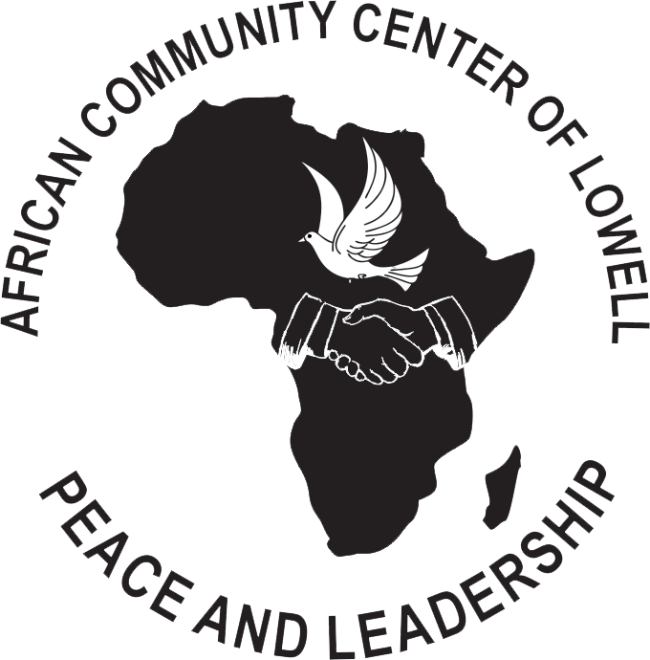

ACCL SUMMER SCHOOL
African Community Center of Lowell 99 Church Street
Lowell, MA 01852
www.acclowell.org info@acclowell.org
(978)-654-5678
Student Registration Form

Please fill out the form carefully for registration and return to the African Community Center of Lowell.

- You can email completed registration form to office@acclowell.org
- Mail hard copy to address:
African Community Center of Lowell
99 Church Street
Lowell, MA 01852.
Student Name | Student Age | Student School | Student Grade | Allergies

Parent(s) Name: ______________________________________________________________________

Parent(s) Address: ____________________________________________________________________

Parent cell phone(s): ___________________________________________________________________
When parent actually brings child for the first time, they can sign papers that give their permissions for photos/health/etc.

"Thank you again and again for being part of ACCL.
EIN # 84-2740360

